PSA ASSIGNMENT 5 | NUID: 002727445

Name: Padma Prasad Anaokar

GitHub: https://github.com/padmaanaokar/002727445_PSA

Code for Main.java

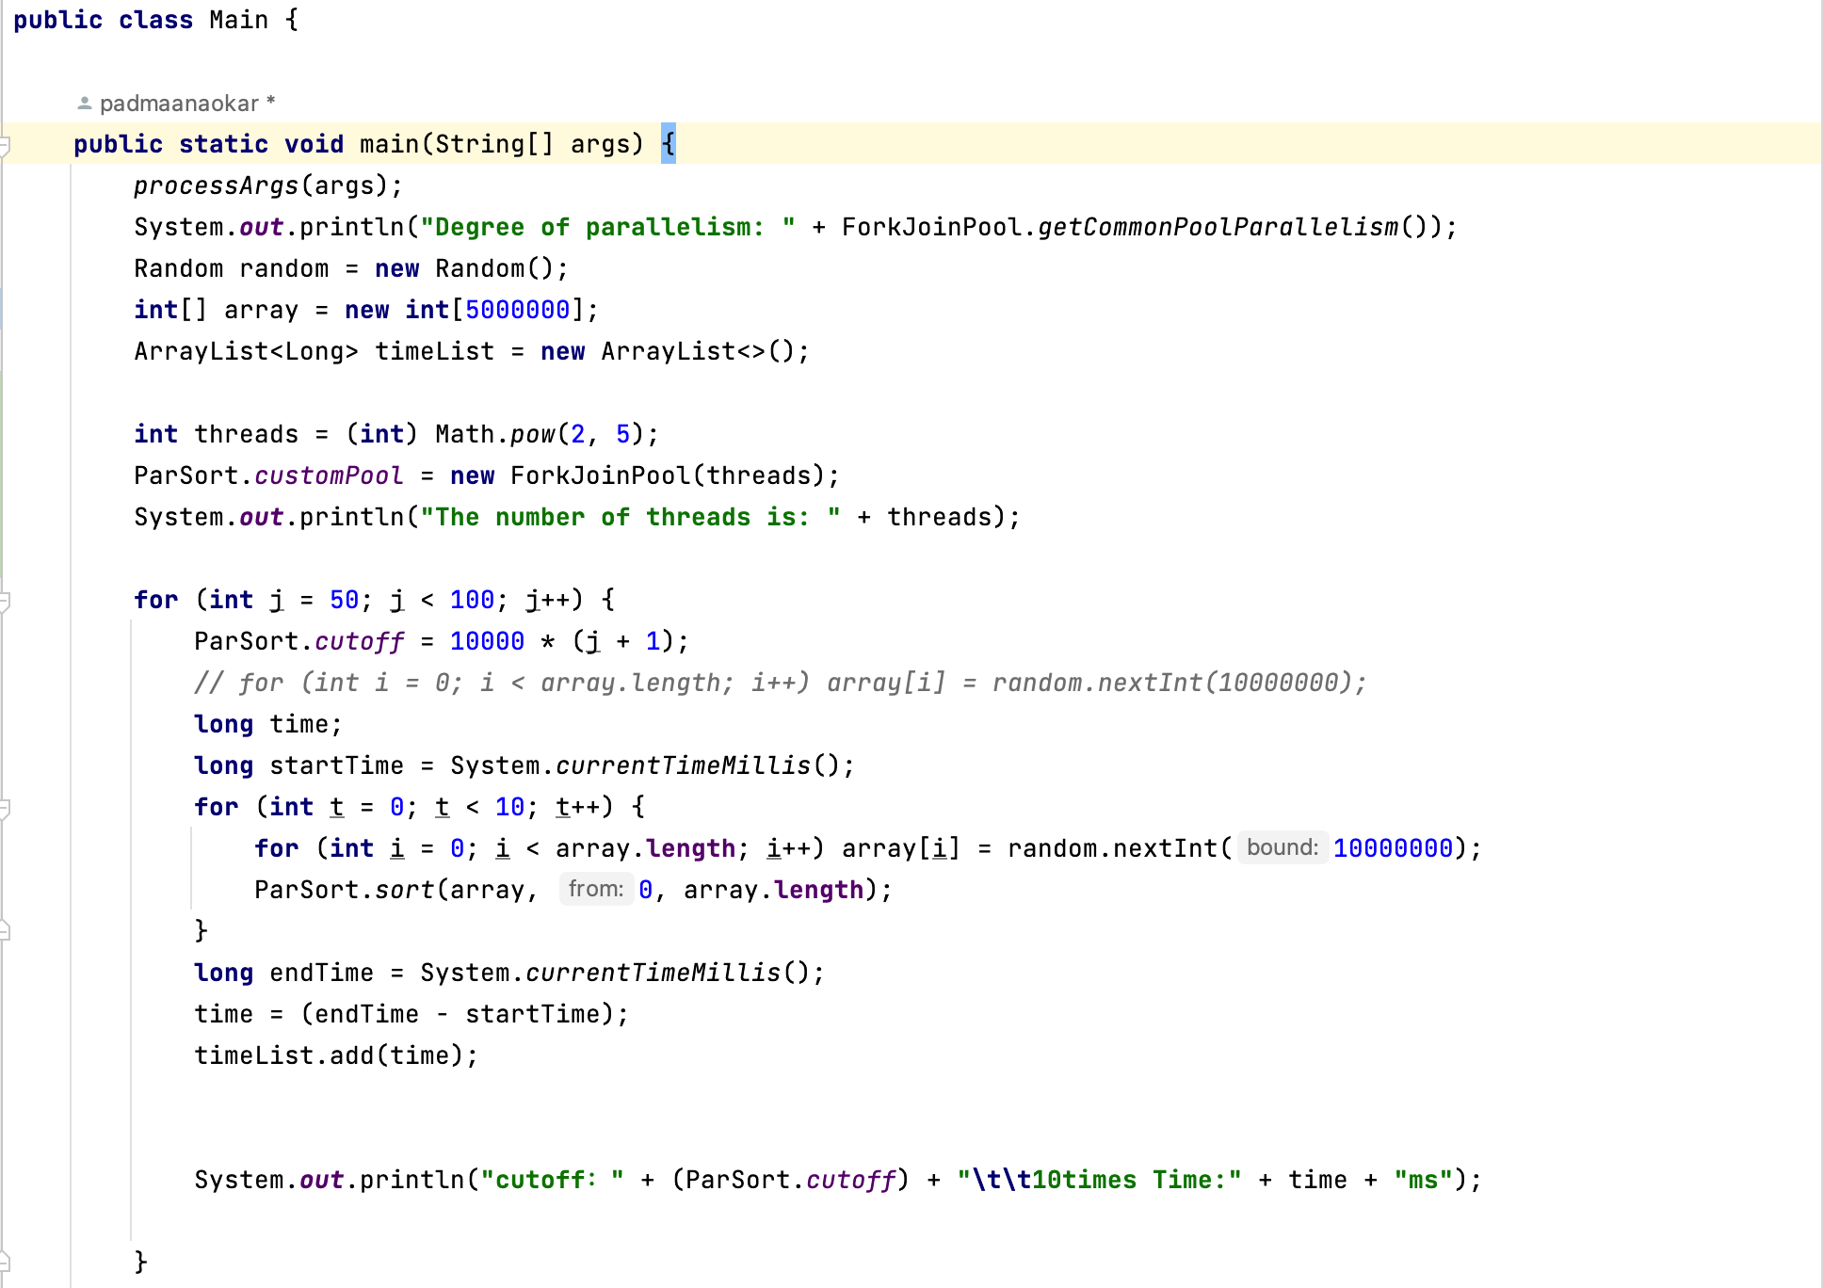

Code for ParSort.java

Execution for threads with power(2,8) for array size 5000000.

Below is the sheet embedded for the experiments performed.



**Conclusion:**

As per the experiments performed it is seen that the performance of sorting depends on the cutoff value and the number of threads. For sorting the larger arrays, parallel sorting is optimal which uses all the resources available to perform the sorting. As we use more number of threads to perform the sorting, the performance increases.

Once the cutoff value is reached performing the sorting of the array with the system sort function seems to be more optimal. As per the experiment runs, if the cutoff value is higher i.e. 1000000 then it is better to increase the number of threads so that the performance is increased. Though here the probability is more likely that we are using system sort more than the parallel sort since the cutoff is larger. But as the array size will increase and the cutoff remains the same we see that parallel sort helps to increase the efficiency of sorting with more number of threads which in our case is 256.